(Please go to Page 3 for the instructions and the Question of this Assignment.)

Student’s Answer Sheet
Student Name: | Babar Ali
Student ID: | BC210426161

Paste script file assignment2 in this box.
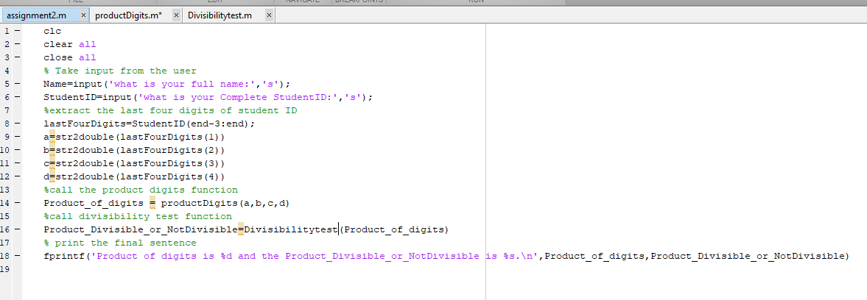

Paste function file ProductDigits in this box.
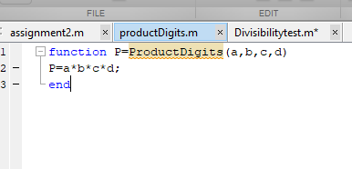

Paste function file DivisibilityTest in this box.
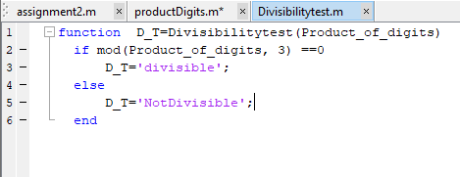

Paste output file from Command Window in this box.
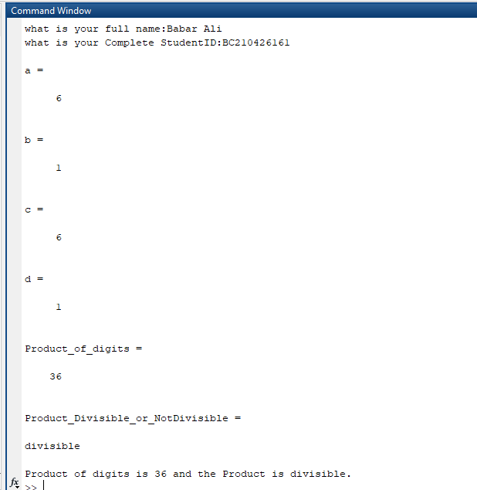

Word file copy past
File name Assignment2.m

clc
clear all
close all
% Take input from the user
Name=input('what is your full name:','s');
StudentID=input('what is your Complete StudentID:','s');
%extract the last four digits of student ID
lastFourDigits=StudentID(end-3:end);
a=str2double(lastFourDigits(1))
b=str2double(lastFourDigits(2))
c=str2double(lastFourDigits(3))
d=str2double(lastFourDigits(4))
%call the product digits function
Product_of_digits = productDigits(a,b,c,d)
%call divisibility test function
Product_Divisible_or_NotDivisible=Divisibilitytest(Product_of_digits)
% print the final sentence
fprintf('Product of digits is %d and the Product is %s.\n',Product_of_digits,Product_Divisible_or_NotDivisible)

productdigit.m
function P=ProductDigits(a, b, c, d)
P=a*b*c*d;
end
divisibilityTest.m
function D_T=Divisibilitytest(Product_of_digits)
if mod(Product_of_digits, 3) ==0
D_T='divisible';
else
D_T='NotDivisible';
end

Assignment # 02 MTH643 (Spring 2024)
Total Marks: 10 Due Date: 02-07-2024
DON’T MISS THESE: Important instructions before attempting the solution and submission of this assignment:
- Lectures 7-11 are encompassed in Assignment 2.

- All students (of both sections) shall complete this Assignment.

- All your answers, such as name, student ID, and MATLAB script, functions and output files must be put inside the allocated boxes (fields) provided in the Student’s Answer Sheet.

- Only the Student’s Answer Sheet will be marked. So, you may choose to only upload your Student’s Answer Sheet. Answers written outside of the boxes may get Zero mark.

- Any copied work, for example, script, functions, and output of some other student’s ID will get Zero mark.

- Assignment 2 is due on July 02, 2024.

- Properly Upload the Student’s Answer Sheet completed in MS Word format on LMS as per the previous practice.

Question: Open MATLAB Software And perform the following steps:
- Create a new script file and name it assignment2.
- Take an input from the user asking the user What is your full name: and save the input in a variable Name.
- Take an input from the user asking the user What is your complete student ID: and save the input in a variable StudentID.
- Save the last four digits of your student ID in the variables a, b, c and d using some MATLAB command. (Do NOT assign the digits manually). For example, a student having ID MC210345678 will have 5 assigned to a, 6 assigned to b, and so on.
- Create a new function file and name it ProductDigits. This function will take four input parameters: a, b, c, d and will give one output parameter: P. The task of this function is to multiply the variables a, b, c, d and to save the product in the variable P.
- In your assignment2 script file, call the function ProductDigits passing the input parameters a, b, c, d to the function and store the output parameter (P) of the function in a variable Product_of_digits.
- Create a new function file and name it DivisibilityTest. This function will take one input parameter Product_of_digits and will give one output parameter: D_T. The task of this function is to check if the variable Product_of_digits is divisible by 3 or not and to save the word Divisible or NotDivisible in the variable D_T.
- In your assignment2 script file, call the function DivisibilityTest passing the input parameter Product_of_digits to the function and store the output parameter (D_T) of the function in a variable Product_Divisible_or_NotDivisible.
- Finally using fprintf command, generate the following sentence:
Product of digits is 1680 and the Product is Divisible.
Note: This product of 1680 and the Divisible is for a dummy Student ID: MC210345678. You will do all your work with your actual student ID.
- Run the script to verify that everything runs right. When it prompts your name, write your name and press enter. When it prompts your student ID, write your student ID and press enter. Now you will get the output of your work. (continued to next page)
And then:
- Take a screenshot of the script file assignment2; copy and paste the screenshot in the box titled: Paste script file assignment2 in this box.
- Take a screenshot of the function file ProductDigits; copy and paste the screenshot in the box titled: Paste function file ProductDigits in this box.
- Take a screenshot of the function file DivisibilityTest; copy and paste the screenshot in the box titled: Paste function file DivisibilityTest in this box.
- Take a screenshot of the output file you obtain in the Command Window; copy and paste the screenshot in the box titled: Paste output file from Command Window in this box.
Very Important Note:
- The screenshots must be taken from MATLAB software. These screenshots must be taken along with their MATLAB headings and boundaries. See the sample below and your screenshot must be the same as provided in the sample below.
- Any student who will copy the commands from script, functions or output files and paste them in the answer boxes instead of pasting the screenshots will be awarded zero mark.

A sample of Student’s Answer Sheet:
- Please find below a sample Student’s Answer Sheet for a dummy Student ID: MC210345678.
- You will do all your work with your actual student ID. Otherwise; you may get Zero mark.
- Any student using this sample as his/her answer will also get Zero mark.

(continued to next page)

